Change Admins on Game Day Roster

- Go to www.utahyouthsoccer.net

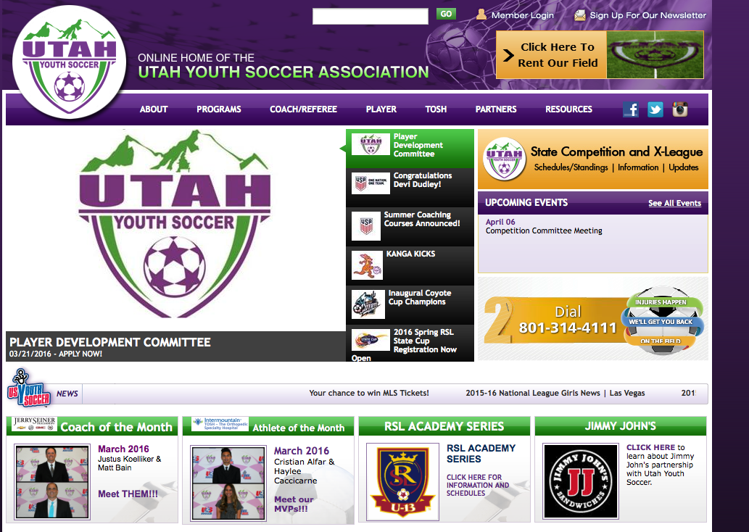
- Click on Member Login

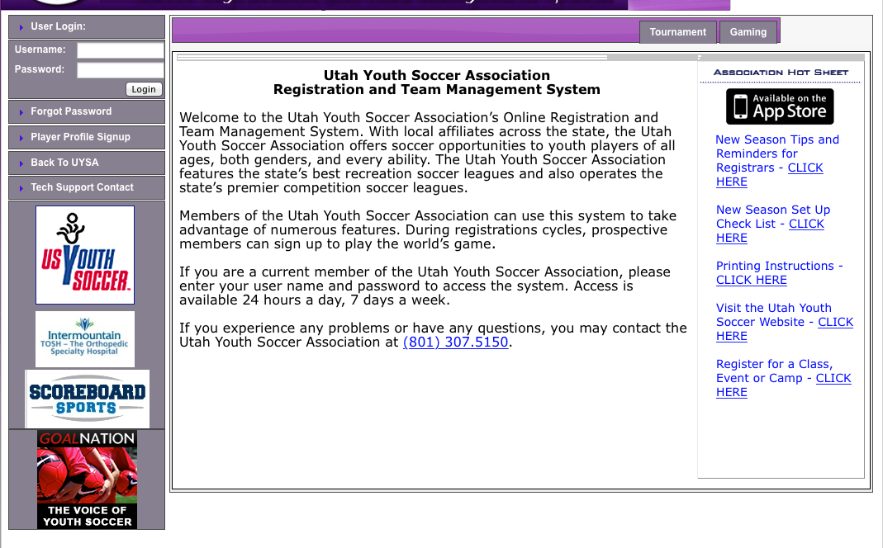
- Sign in by entering your username and password.
- Click on the Teams Tab
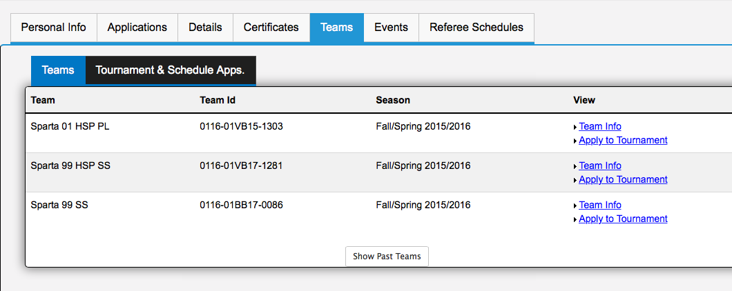
- Click on apply to Tournament link next to the team you want to change.

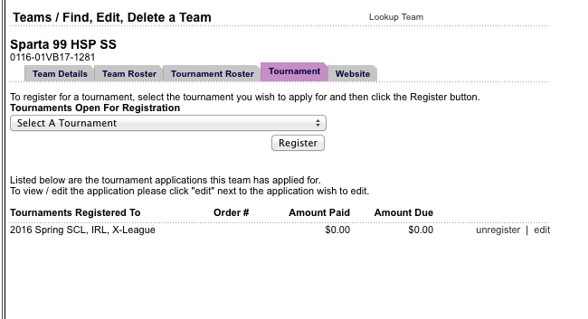

- Click on the edit link

- Click on the contacts tab. Un check the active box next to the coach or admin that you do not want to print on the game day roster.

